FURI budget supplemental folder
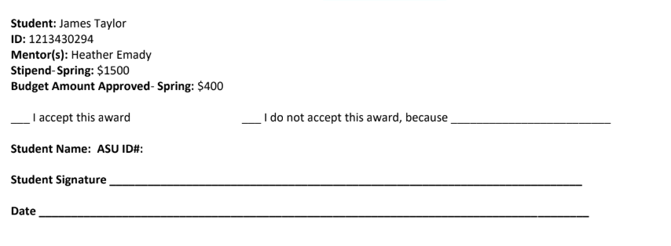
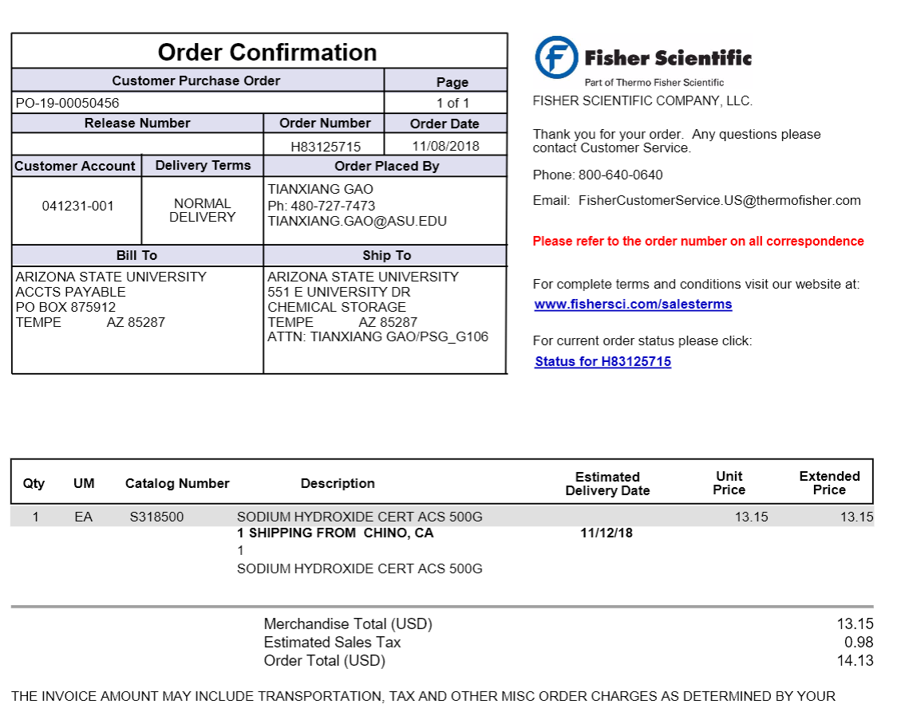
The following in taken from iLab and is the cost of being trained on the AFM
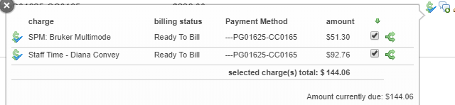
The following the order/payment details of the AFM tips I bought!!
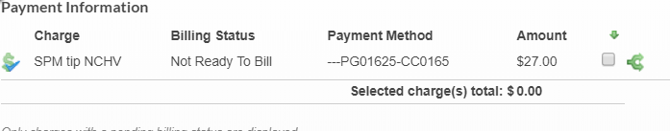

AFM cost estimate
The following is an email describing how to schedule training and a rough estimate to its cost.
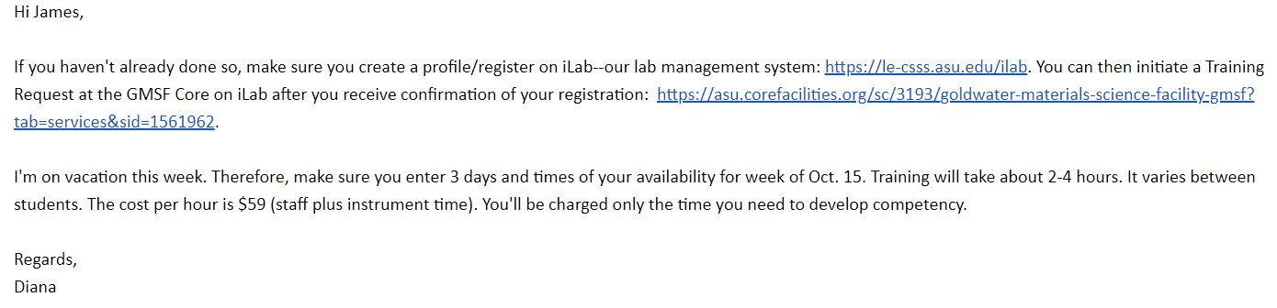
The following is the rates for use of the AFM at ASU
